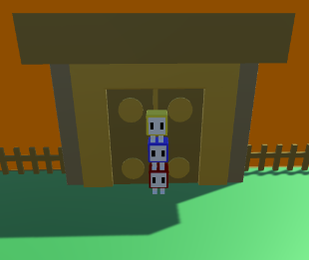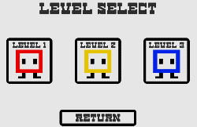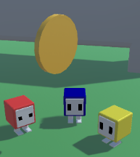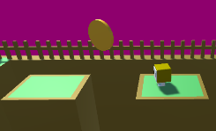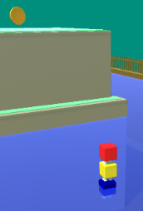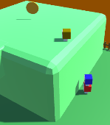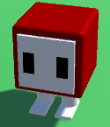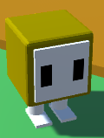

Cubus is a 3D platformer/problem solving game where the player takes control of 1 to 3 different ‘Cubi’ and uses them to collect coins and complete levels by stacking the Cubi on top of each other.

Each ‘Cubi’ have unique abilities that allow for creative problem solving.

The Red ‘Cubi’ can carry other ‘Cubi’ efficiently.

The Yellow ‘Cubi’ can jump twice as high.

The Blue ‘Cubi’ can swim in water.

The game has 3 levels the player can play. After the player completes a level, it is unlocked, and they can choose to play it again from the Level Select Menu.

Each of the 3 levels is built around a ‘Cubi’s’ abilities and can contain:

Blocks to climb by stacking

Water to swim through (and carry other ‘Cubi’ over)

Zones where ‘Cubi’ can’t jump

And Parkour!

